**Application Deployment**

(Deploy the given React application to a production ready state)

**Application:**

Clone the below mentioned repository and deploy the application (Run application in port 3000).

Repo URL : <https://github.com/Vennilavan12/Brain-Tasks-App.git>

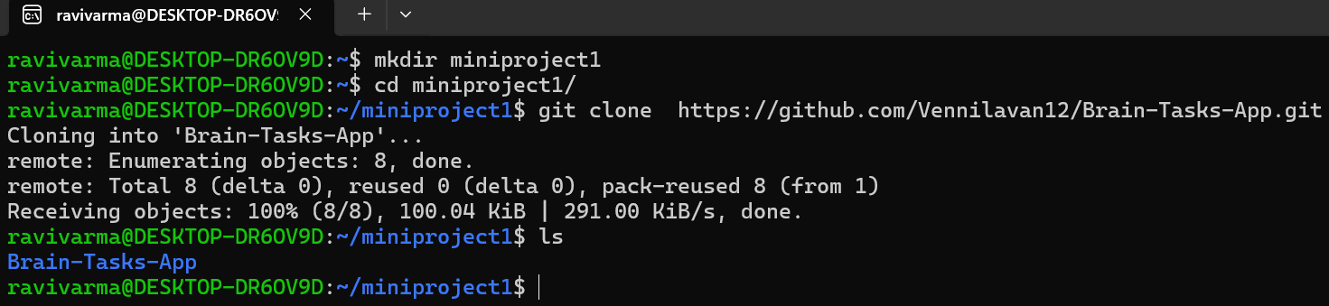

**Docker:**

* Dockerize the application by creating Dockerfile
* Build an application and check output using docker image.

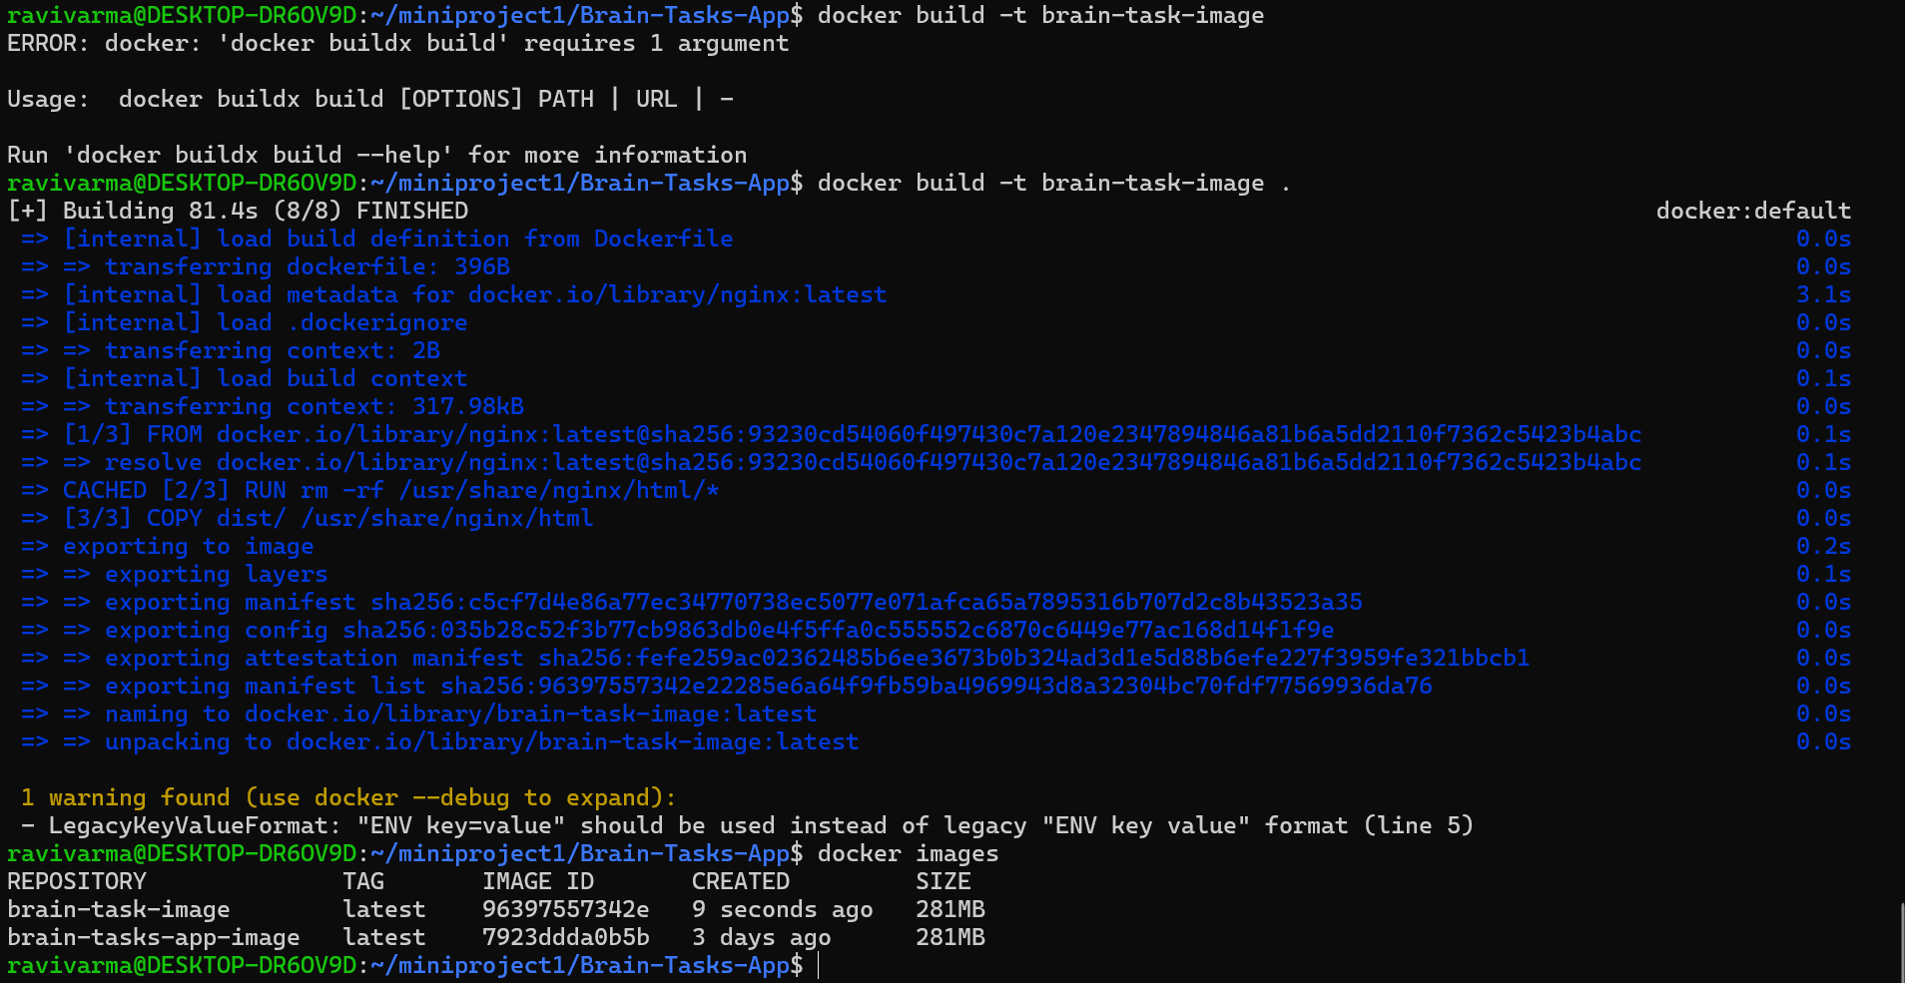

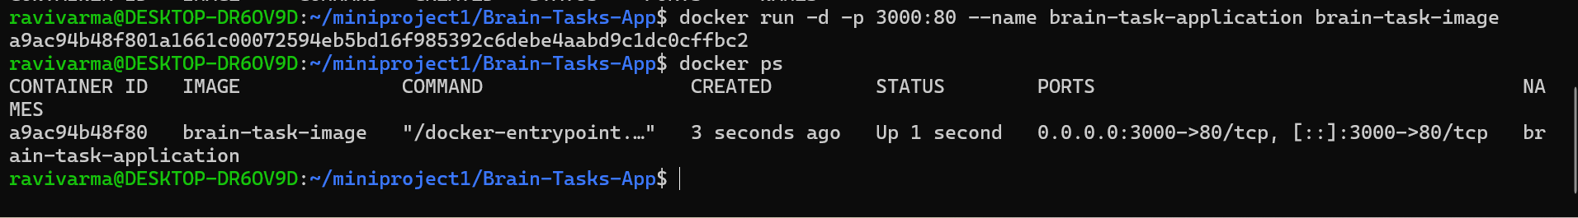

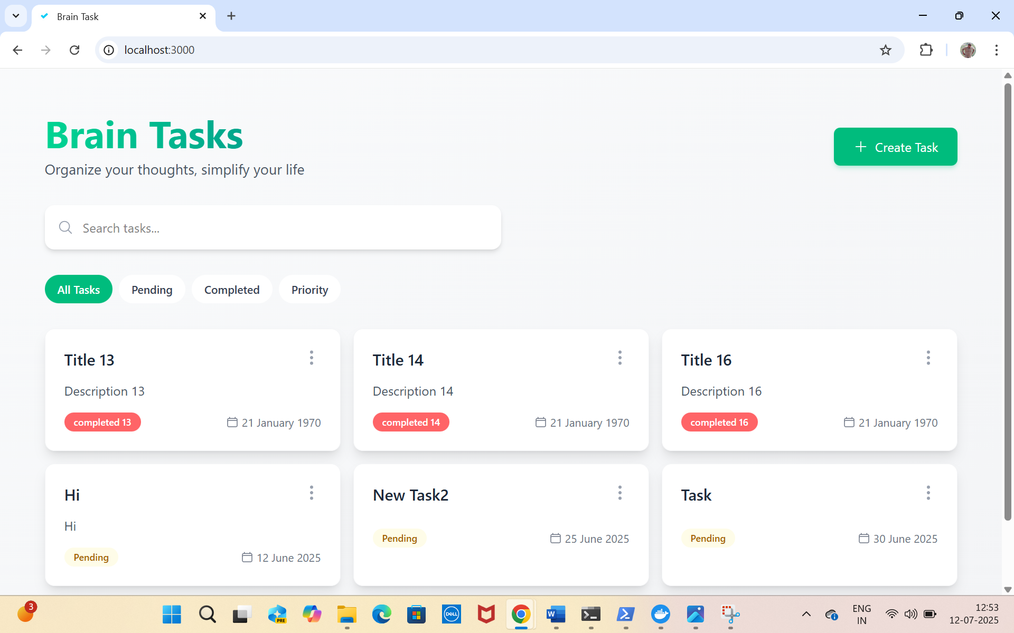

**ECR:**

* Create an AWS ECR repository for store docker images.

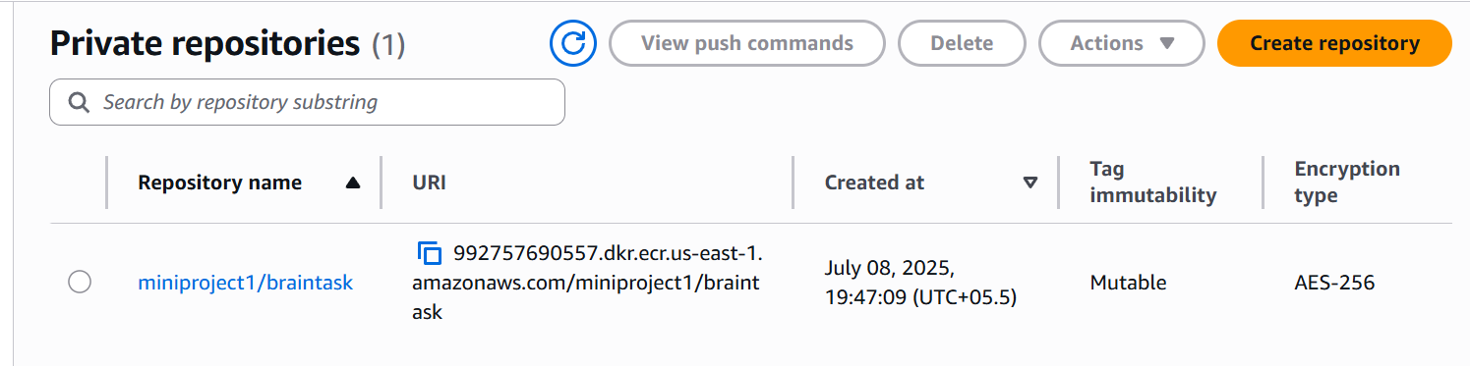



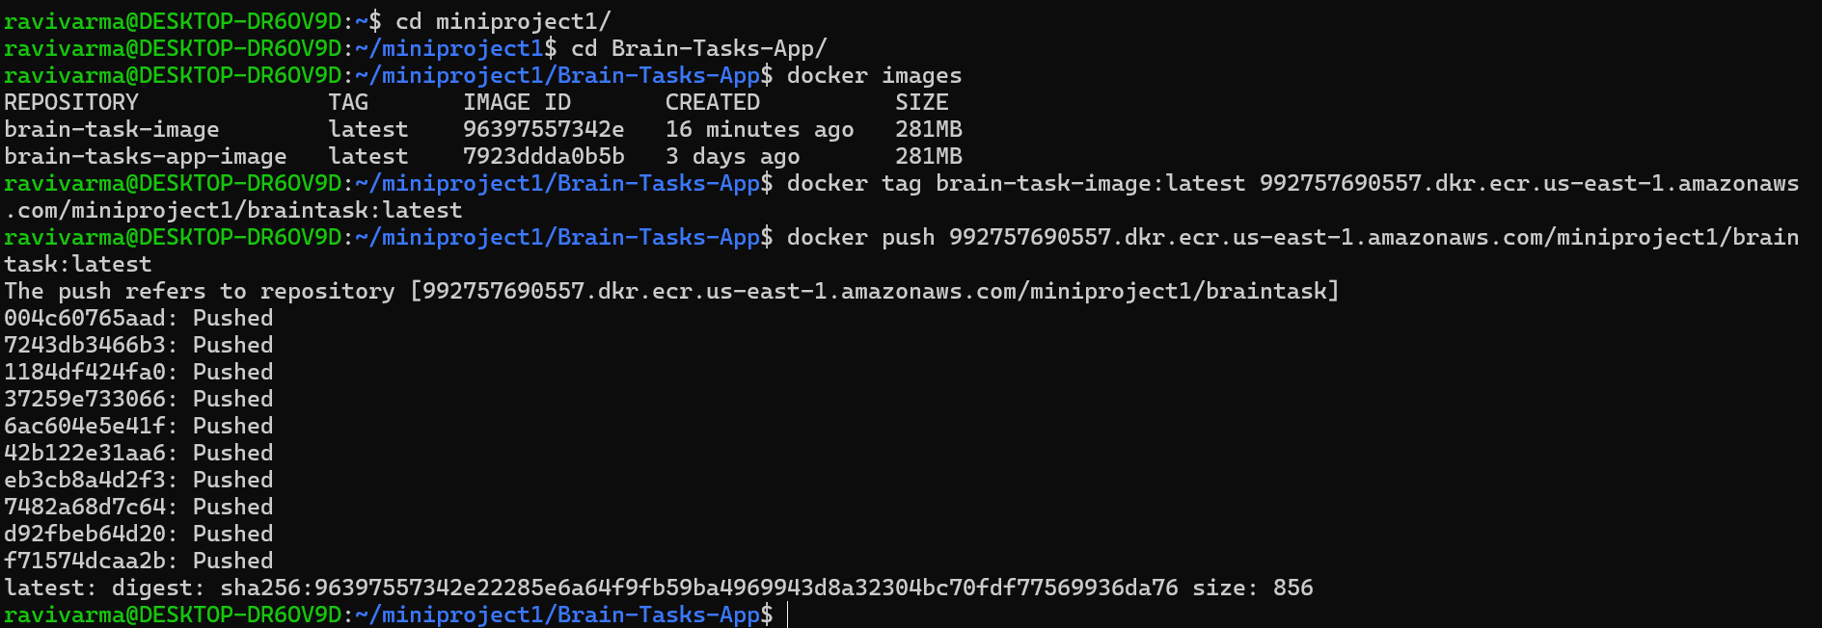

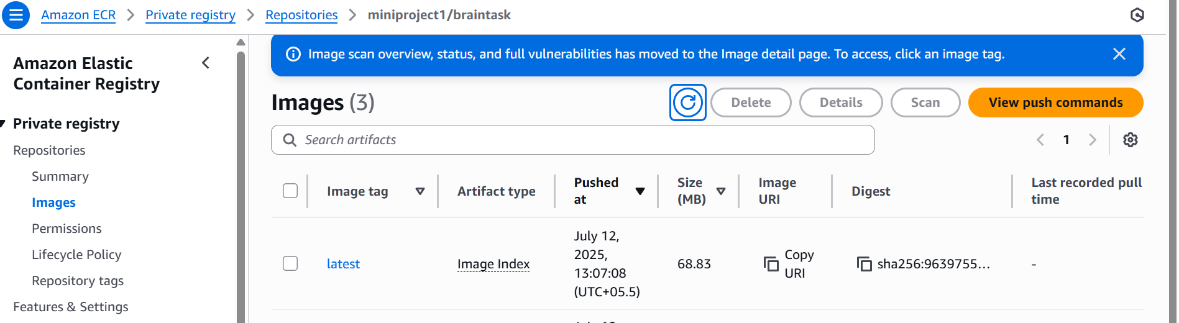

**Kubernetes:**

* Setup Kubernetes in AWS EKS and Confirm EKS cluster is running.

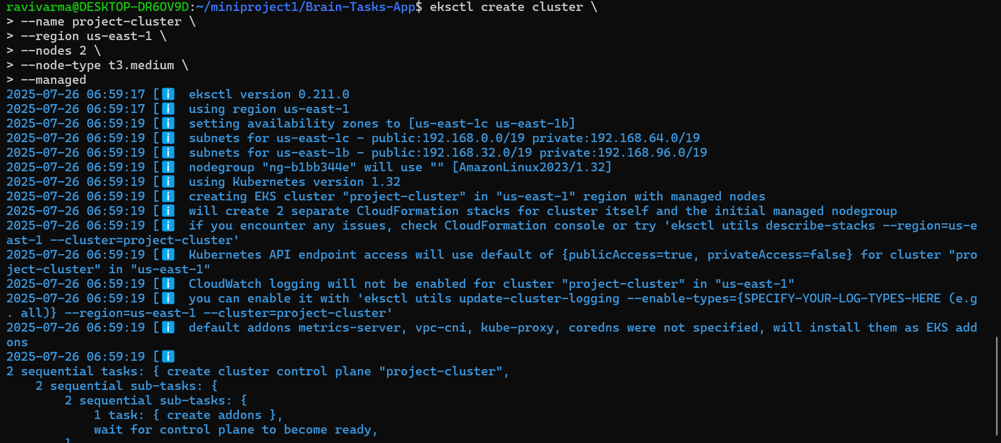

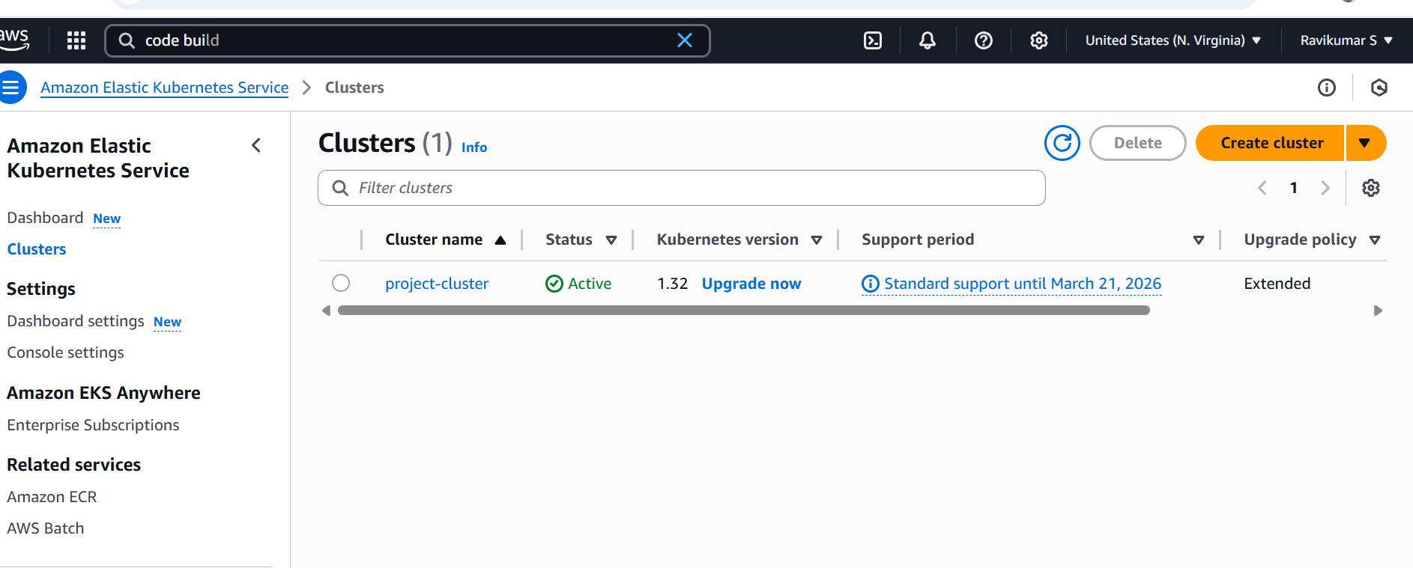

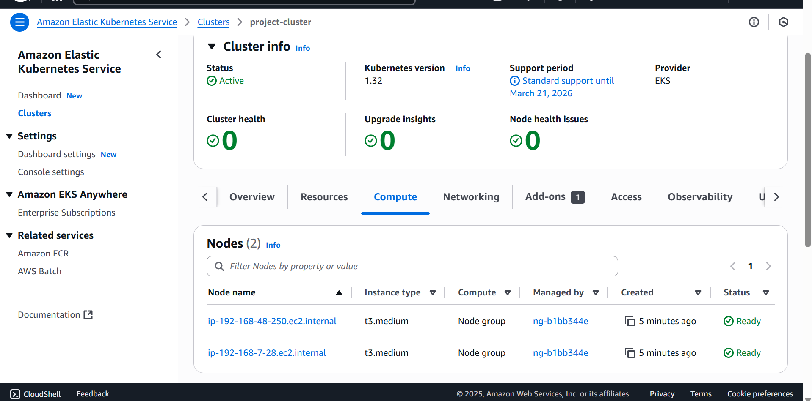

* Write deployment and service YAML files.

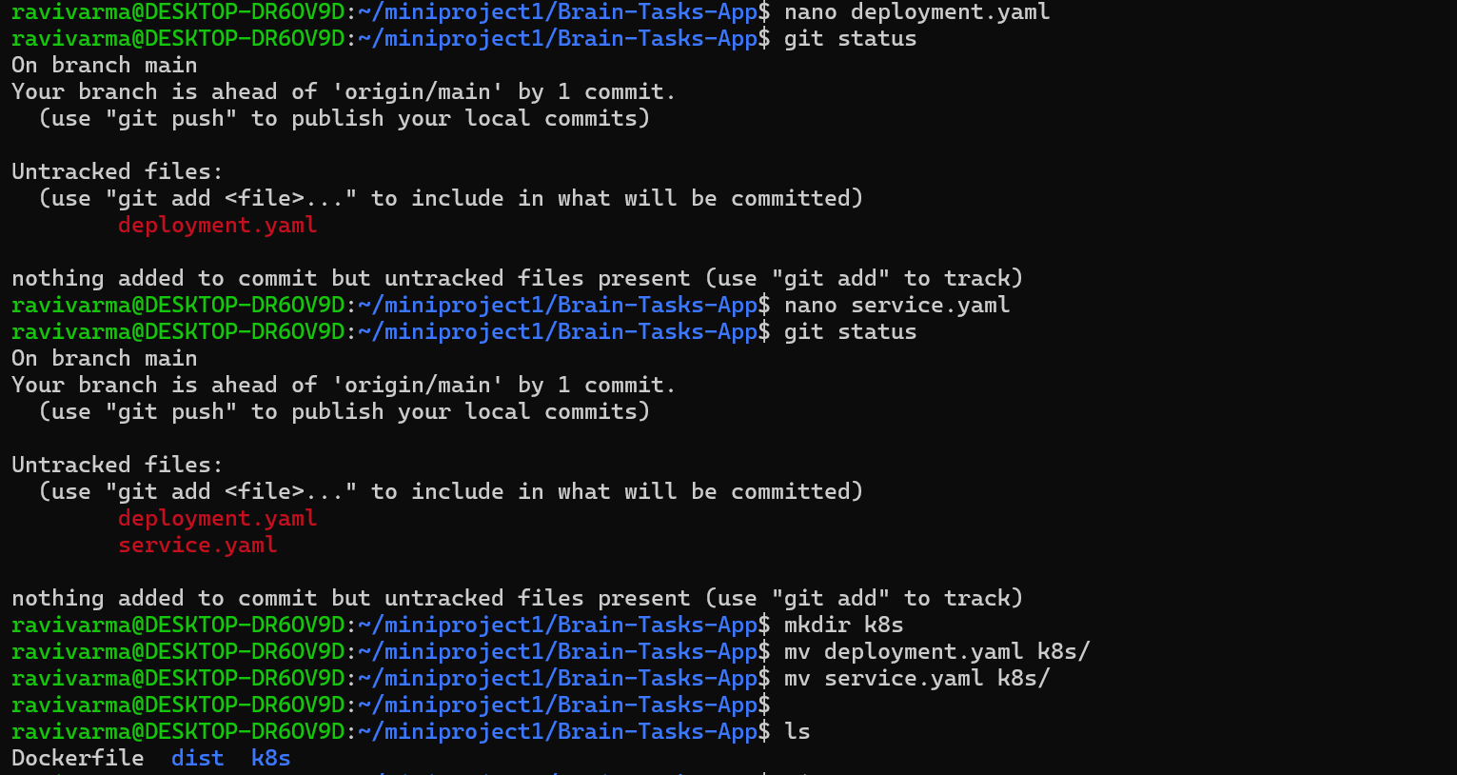

* Deploy using kubectl via Codedeploy.

**CodeBuild:**

* Create a CodeBuild project:
* Source: Connect to your repository
* Environment: Use managed image (Amazon Linux, Ubuntu)
* Write and define commands in buildspec.yml.

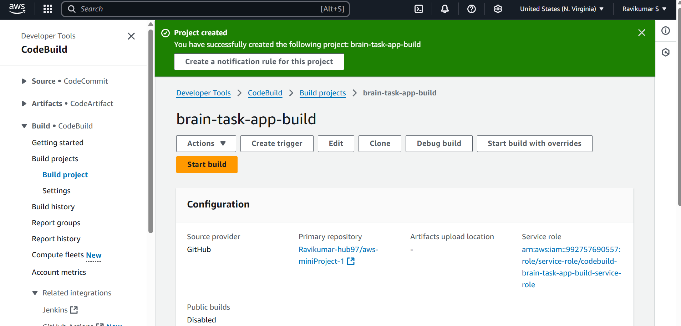

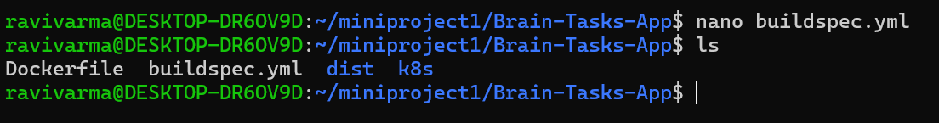

**CodeDeploy:**

* Create codedeploy application.
* create appspec.yml file to deploy applications in EKS.

**Version Control:**

* Push the codebase to a Git provider (GitHub).
* Use CLI commands to push code.

**CodePipeline:**

* Source: GitHub
* Build: AWS CodeBuild project
* Deploy: AWS CodeDeploy or deploy to EKS via Lambda or custom script.

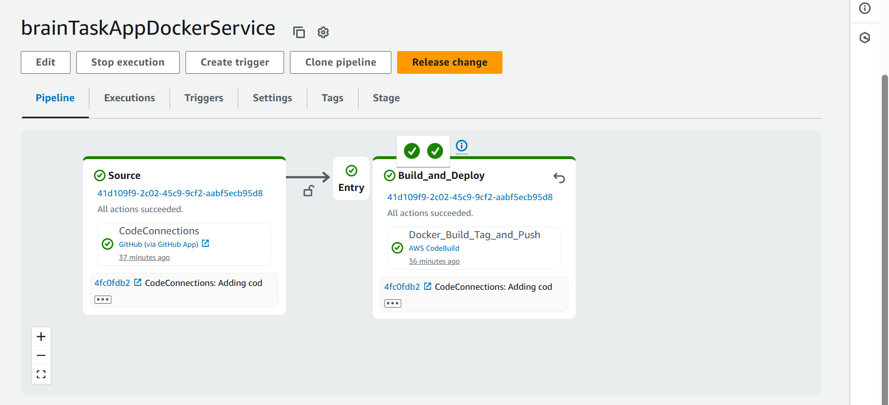

**Monitoring:**

* Use CloudWatch Logs to track build, deploy, and application logs